Process
- 1st install my sql connector
  - Step 1: Install the MySQL Connector
- Go to power bi and follow the below steps

Step 2: Open Power BI

Step 3: Connect to the MySQL Database

Step 4: Select the Required Data

Step 5: Verify the Data

https://dev.mysql.com/downloads/connector/net/

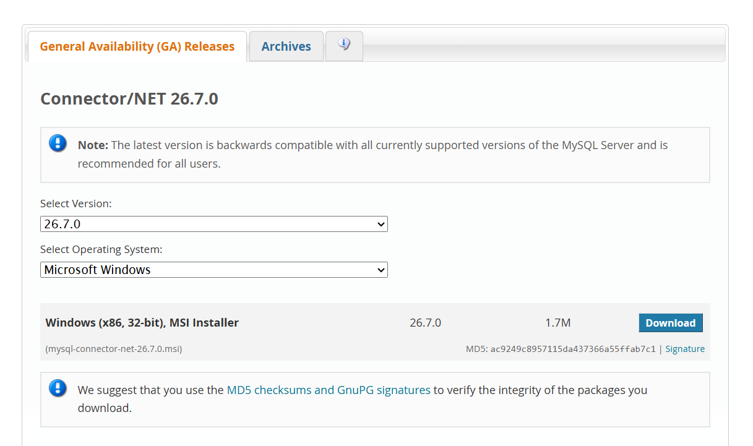
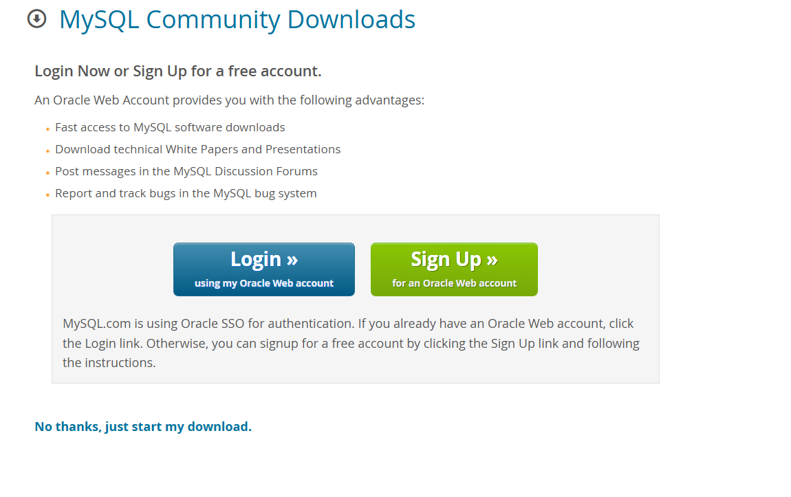

- Go to power bi and follow the below steps (

Step 2: Open Power BI

Step 3: Connect to the MySQL Database

Step 4: Select the Required Data

Step 5: Verify the Data

